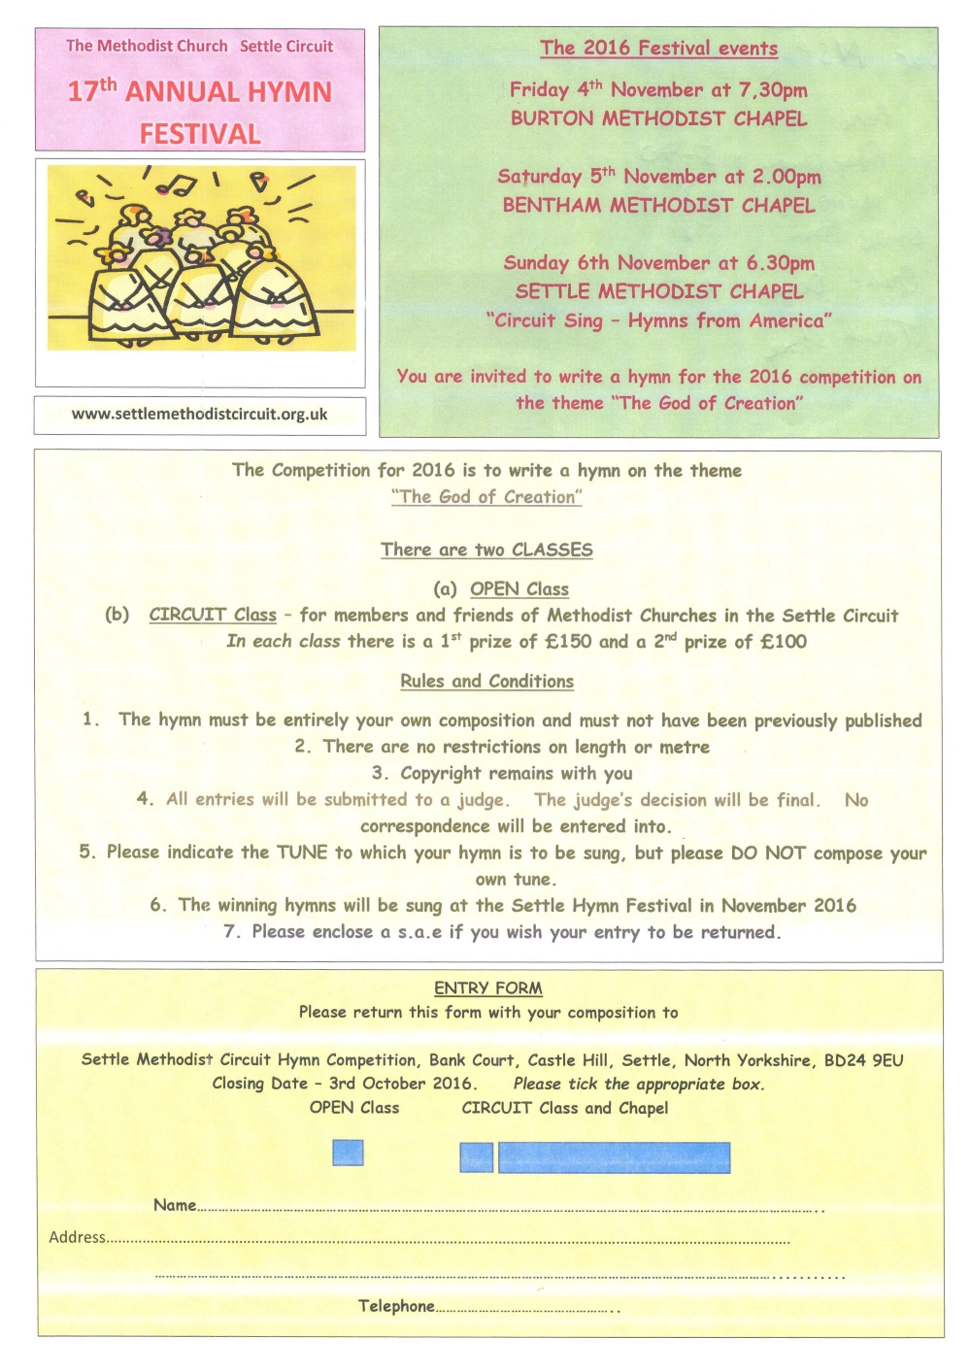

Email: HymnCompetition@settle-methodists.org.uk

