Churches Together in Settle and District Press Release 9 April 2012
DISABILITY AWARENESS AND NEEDS
Do you like to think you are helpful to other people?
This cartoon character is called DAN - which stands for Disability Awareness and Needs. DAN will be helping raise awareness in the Settle area of how we can help each other become more aware of People's Needs.
Often needs are hidden. We don't realise we need to help
Sometimes needs are obvious - but we don't know how to help.
Come to the talk organised by Churches Together in Settle and District on "Disability Awareness" to be given by Debi Burridge on Wednesday 18 April at St John's Church Hall, Settle, BD24 9JH, starting at 7pm with a cup of tea.
Debi says:
"We can help people (including ourselves) who suffer from features such as deafness, blindness, depression, mental needs, memory loss and mobility problems if we are more aware. Come and learn how to be more aware."
This talk will be useful to people who would like to help their club / school / hotel / family / friends more effectively. i.e. everyone. www.ctisad.org.uk 01729 822138 Debi used to work for a firm which advised firms (e.g. hotels, doctors surgeries) on Disability Awareness.
ENDS--------------
CONTACT:- Judith Allinson 01729 822138 jallinson@daelnet.co.uk
NOTES:-
A small DAN group (Disability Awareness and Needs group) has set up in Churches Together in Settle and District to encourage people in the churches to be more aware, and hopefully as a spin-off, people in the rest of Settle. They are keen for people to help with their questionnaire.
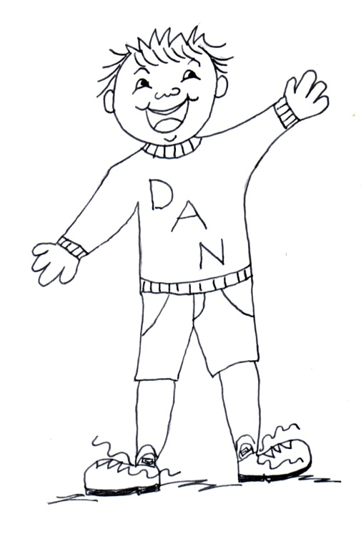
Judith Allinson says "This is a grass roots project, in response to local needs. We will include publicity for the work of existing organisations such as AGE UK and SCAD. Churches Together in Settle ran a successful series of lectures on "End of Life Issues" in 2011, and in some ways this is a follow on. As Britain is looking after an increasingly aging population, people in other areas may be interested to know what we are doing here, so I am sending this out as a national press release." People in the DAN group come from several churches in Settle including Methodist, Catholic and Anglican and Quaker.
TEXT OF THE POSTER-
Wed - 18 April – 7pm St John's Church Hall, Settle BD24 9JH
Talk by Debi Burridge on "Disability Awareness - Helping each other become more aware of People's Needs."
This is for everyone
We can help people (including ourselves) who suffer from features such as deafness, blindness, depression, mental needs, memory loss and mobility problems if we are more aware. Come and learn how to be more aware. It may help you organise your club / school / hotel /group more effectively. Starts 7pm with cup of tea.
Organised by Churches Together in Settle on behalf of all in Settle and District -
www.ctisad.org.uk 01729 822138

