..
Disability

Awareness

Wed - 18 April – 7pm
St John's Church Hall, Settle BD24 9JH
Talk by Debi Burridge
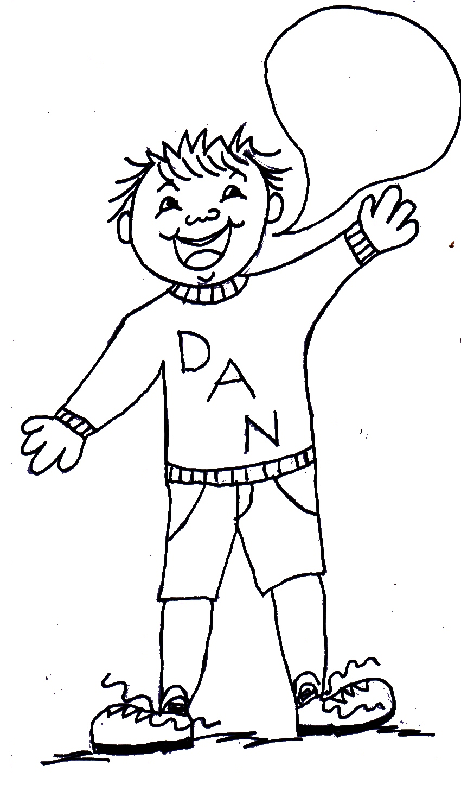
Helping each other become more aware of People's Needs.
This is for everyone
.
All
We can help people (including ourselves) who suffer from features such as deafness, blindness, depression, mental needs, memory loss and mobility problems if we are more aware.
Come and learn how to be more aware. It may help you help your club / school / hotel / group / family / friends more effectively. Starts 7pm with cup of tea. Organised by Churches Together in Settle on behalf of all in Settle and District - www.ctisad.org.uk 01729 822138
welcome
..
Disability

Awareness

Wed - 18 April – 7pm
St John's Church Hall, Settle BD24 9JH
Talk by Debi Burridge
Helping each other become more aware of People's Needs.
This is for everyone
.
All
We can help people (including ourselves) who suffer from features such as deafness, blindness, depression, mental needs, memory loss and mobility problems if we are more aware.
Come and learn how to be more aware. It may help you help your club / school / hotel / group / family / friends more effectively. Starts 7pm with cup of tea. Organised by Churches Together in Settle on behalf of all in Settle and District - www.ctisad.org.uk 01729 822138
welcome
..
Disability

Awareness

Wed - 18 April – 7pm
St John's Church Hall, Settle BD24 9JH
Talk by Debi Burridge
Helping each other become more aware of People's Needs.
This is for everyone
.
All
We can help people (including ourselves) who suffer from features such as deafness, blindness, depression, mental needs, memory loss and mobility problems if we are more aware.
Come and learn how to be more aware. It may help you help your club / school / hotel / group / family / friends more effectively. Starts 7pm with cup of tea. Organised by Churches Together in Settle on behalf of all in Settle and District - www.ctisad.org.uk 01729 822138
welcome
..
Disability

Awareness

Wed - 18 April – 7pm
St John's Church Hall, Settle BD24 9JH
Talk by Debi Burridge
Helping each other become more aware of People's Needs.
We can help people (including ourselves) who suffer from features such as deafness, blindness, depression, mental needs, memory loss and mobility problems if we are more aware. Come and learn how to be more aware.
All
welcome
Starts 7pm with cup of tea.
Organised by Churches Together on behalf of all in Settle and District
www.ctisad.org.uk 01729 822138

