Speaking
T
Craven Speakers
Soroptimists Rooms
28, Otley St, Skipton, BD23 1EW
www.craven-speakers.org.uk
Alt. Mondays - 7.40pm for 8pm
11,25 Sep; 9,23 Oct;
6,30 Nov; 4,18 Dec
01535-652915

Become a
better speaker,
better presenter,
better leader
Craven Speakers is a member of the Association of Speakers Clubs: www.the-asc.org.uk
ps

“Entertaining” “Fun” “Stimulating” “Supportive”

Just some of the words used to describe
Craven Speaker Club meetings

Come for a novel evening out:- Find out what goes on at

Craven Speakers Club

starts
Mon 11 Sep
Soroptimists Rooms
28, Otley St, Skipton, BD23 1EW
www.craven-speakers.org.uk
Alt. Mondays - 7.40pm
11,25 Sep; 9,23 Oct; 6,30 Nov; 4,18 Dec
01535-652915
Become a better speaker, better presenter, better leader

Yes:You
can speak!

Do you need to give
- a wedding speech?

- a talk at school or work?

You are not alone in wanting to be a better speaker. Join us at

Craven Speakers Club

ou will:

The Soroptimists Rooms, 28, Otley Street, Skipton, BD23 1EW

Skipton: Alternate Mondays - 7.40 pm
11,25 Sep; 9,23 Oct; 6,30 Nov; 4,18 Dec
www.craven-speakers.org.uk 01535-652915
www.the-asc.org.uk

It’s fun

Is public speaking
a challenge to you?

☻ Business presentation
☻ New job ☻ Wedding speech?

Bite the bullet

We welcome you at Skipton, at
Craven Speakers
Tips, Tricks, Techniques and Practice
amongst friendly, supportive co-learners.

Absolute beginners welcome


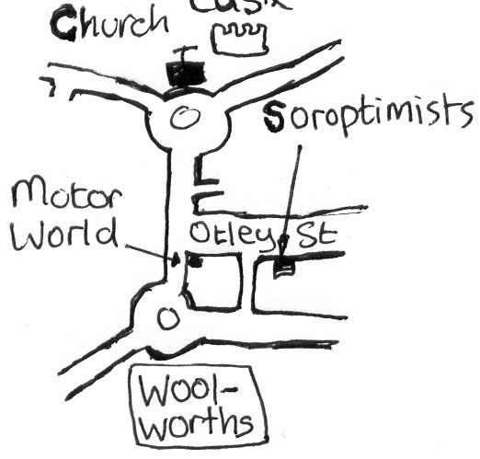
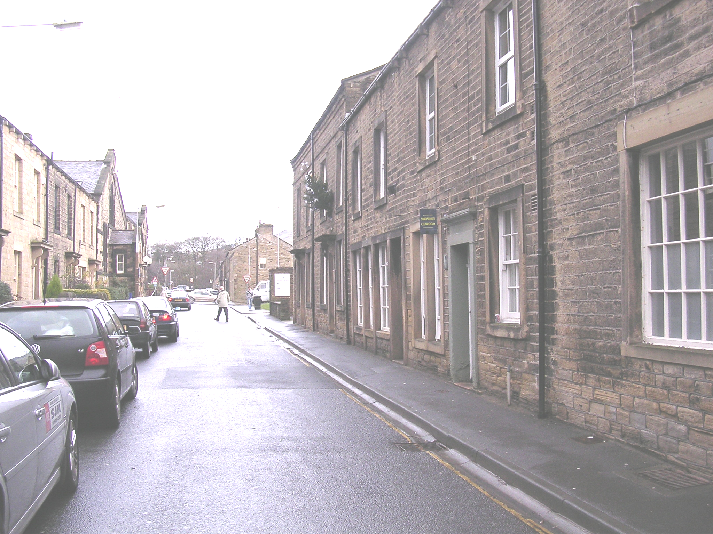

Soroptimists Rooms, 28,
Otley St, Skipton, BD23 1EW
www.craven-speakers.org.uk
Alt. Mondays - 7.40pm
11,25 Sep; 9,23 Oct; 6,30 Nov; 4,18 Dec
01535-652915

Have a Brilliant Fun Evening Out
10 Top Tips for Speaking
- Practise speaking the speech out loud beforehand
- Use a camera to video yourself giving the speech- watch it and work out how you can improve
- Two minutes before you are due to start, sit up (or stand) shoulders back, in very open, powerful relaxed stance. It will make you feel and speak better.
- Before you start to speak, stop, look round the room, and give everyone a beaming smile.
- Instead of saying “Err” or “Umm”, take a breath
- Make sure you have a “Call to action”, best given just before the end, or at the end of the speech.
- Have a dramatic strong sentence with which to finish
- Practise 9. Practise 10. Practise

Learn more tips, & come for an entertaining fun evening out at
Craven Speakers
Soroptimists Rooms
28, Otley St, Skipton, BD23 1EW
Alt. Mondays - 7.40pm
11,25 Sep; 9,23 Oct; 6,30 Nov; 4,18 Dec
www.craven-speakers.org.uk 01535-652915

ASC
Association of
Speakers Clubs
www.the-asc.org.uk
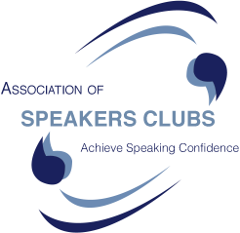

Achieving Speaking Confidence
The ASC has
- 100 affiliated clubs in UK (locations on website)
- over 40 years experience of helping people
- enables you to practise, practise, practise
- useful resources – tips, tricks, techniques
- a programme to help you improve

- and FUN!

01535 652915
Lose your Fear
of Public Speaking

It’s a fear that affects over 90% of the population, yet for those of us who are willing to overcome it, great rewards await

What is a Speakers Club?
Speakers Clubs exist with the aim of giving you a safe environment in which to increase you confidence in speaking to an audience.. A structured 10 step process ensures everyone keeps improving. For example, the level 1 speech is a 5 minute talk on a subject of your choice with no pressure and lots of support from the group.

Tips, Tricks, Techniques ...& Fun
One member said: “I am really glad I started. My speech making has improved so much. I have met a great new group of people. I really do wish I had started at the beginning of my career.”

Craven Speakers Club, Skipton
Meets fortnightly Sept to May, Mondays 7.40pm at The Soroptimists, 28 Otley St, Skipton, BD23 1EW www.craven-speakers.org.uk (50% Discount for people aged 16-18) info: 07984181587 01535 665278.
2017:- 11,25 Sep; 9,23 Oct; 6,30 Nov; 4,18 Dec
.You gain:-

Fun, Support, Improvement
Join one of the 100 speakers clubs in the UK
www.the-asc.org.uk

Confidence
Credibility Charisma
at

Craven Speakers Club

- Speak to a group?
- New job?
- Wedding?

Tips, Tricks, Techniques and Practice
amongst supportive co-learners
Absolute beginners welcome
Soroptimists Rooms, 28,
Otley St, Skipton, BD23 1EW
www.craven-speakers.org.uk
Alt. Mondays - 7.40pm
11,25 Sep; 9,23 Oct;
6,30 Nov; 4,18 Dec
01535-652915

New job?
Wedding speech?

Need to speak to a group of people?
Want a fun evening class?
Tips, Tricks, Techniques and Practice amongst Supportive Co-learners.
Absolute beginners welcome at
Craven Speakers
Soroptimists Rooms, 28,
Otley St, Skipton, BD23 1EW
www.craven-speakers.org.uk
Alt. Mondays - 7.40pm
11,25 Sep; 9,23 Oct;
6,30 Nov; 4,18 Dec
01535-652915

New job?
Wedding speech?

Need to speak to a group of people?
Want a fun evening class?
Tips, Tricks, Techniques and Practice
amongst Supportive Co-learners
Absolute beginners welcome at
Craven Speakers
Soroptimists Rooms, 28,
Otley St, Skipton, BD23 1EW
www.craven-speakers.org.uk
Alt. Mondays - 7.40pm
11,25 Sep; 9,23 Oct;
6,30 Nov; 4,18 Dec
01535-652915

Need Confidence?

Tips for: Speaking
Craven Speakers
for practice for new job, wedding speeches, business presentations
social speaking

Soroptimists Rooms, 28,
Otley St, Skipton, BD23 1EW
www.craven-speakers.org.uk
Alt. Mondays - 7.40pm
11,25 Sep; 9,23 Oct;
6,30 Nov; 4,18 Dec
01535-652915

Afraid?
of public speaking?

☻ Business presentation
☻ New job? ☻ Wedding speech?

Bite the bullet

We welcome you at Skipton, at
Craven Speakers
Tips, Tricks, Techniques and Practice
amongst friendly, supportive co-learners

Absolute beginners welcome

28, Otley St, Skipton, BD23 1EW

www.craven-speakers.org.uk

Alt. Mondays - 7.40pm
11,25 Sep; 9,23 Oct;
6,30 Nov; 4,18 Dec
01535-652915

Have fun improving your
speaking skills
for public speaking or just talking to your friends
Tips for gaining confidence and speaking more effectively

Craven Speakers Club
Skipton
Alternate Mondays
7.40 for 8pm


11,25 Sep; 9,23 Oct; 6,30 Nov; 4,18 Dec
The Soroptimists Rooms, 28, Otley St., Skipton, BD23 1EW
01535 633730/665278
www.craven-speakers.org.uk

More clubs at: York, Wetherby, Otley, Leeds, Halifax,
Morecambe, Garstang, Clitheroe, Burnley+ Bradford

Speak with confidence

Craven Speakers
Soroptimists Rooms
28, Otley St, Skipton, BD23 1EW
www.craven-speakers.org.uk
Alt. Mondays - 7.40pm
11,25 Sep; 9,23 Oct;
6,30 Nov; 4,18 Dec
01535-652915
Become a better speaker, better presenter, better leader

Become a
—
better speaker better presenter better leader

Craven Speakers

Soroptimists Rooms
28, Otley St, Skipton, BD23 1EW
www.craven-speakers.org.uk
Alt. Mondays - 7.40pm
11,25 Sep; 9,23 Oct;
6,30 Nov; 4,18 Dec
01535-615529
New job?
Wedding speech?

Craven Speakers
Soroptimists Rooms
28, Otley St, Skipton, BD23 1EW

www.craven-speakers.org.uk
Alt. Mondays - 7.40pm
11,25 Sep; 9,23 Oct; 6,30 Nov; 4,18 Dec
01535-652915
Become a better speaker, better presenter, better leader

Confidence?

Tips for: Speaking

Craven Speakers
Soroptimists Rooms
28, Otley St, Skipton, BD23 1EW
www.craven-speakers.org.uk
Alt. Mondays - 7.40pm
11,25 Sep; 9,23 Oct;
6,30 Nov; 4,18 Dec
01535-652915
Become a better speaker, better presenter, better leader

Speaking
T
Craven Speakers
Soroptimists Rooms
28, Otley St, Skipton, BD23 1EW
www.craven-speakers.org.uk
Alt. Mondays - 7.40pm for 8pm
11,25 Sep; 9,23 Oct;
6,30 Nov; 4,18 Dec
01535-652915

Become a
better speaker,
better presenter,
better leader
Craven Speakers is a member of the Association of Speakers Clubs: www.the-asc.org.uk
ps

“Entertaining” “Fun” “Stimulating” “Supportive”

Just some of the words used to describe
Craven Speaker Club meetings

Come for a novel evening out:- Find out what goes on at

Craven Speakers Club

starts
Mon 11 Sep
Soroptimists Rooms
28, Otley St, Skipton, BD23 1EW
www.craven-speakers.org.uk
Alt. Mondays - 7.40pm
11,25 Sep; 9,23 Oct; 6,30 Nov; 4,18 Dec
01535-652915
Become a better speaker, better presenter, better leader
Craven Speakers Club
Re starts this autumn:-
Mon 11 Sep

Come for a novel evening out:- Find out what goes on and learn some speaking tips in the process
“Entertaining” “Fun” “Stimulating” “Supportive”
Soroptimists Rooms, 28, Otley St, Skipton, BD23 1EW
www.craven-speakers.org.uk
Alt. Mondays - 7.40pm
11,25 Sep; 9,23 Oct; 6,30 Nov; 4,18 Dec
01535-652915
New job?
Wedding speech?
Or just fancy a fun, entertaining evening out? We can help you.
Craven Speakers

Soroptimists Rooms
28, Otley St, Skipton, BD23 1EW
www.craven-speakers.org.uk

Alt. Mondays - 7.40pm
11,25 Sep; 9,23 Oct; 6,30 Nov; 4,18 Dec
01535-652915
Become a better speaker,
better presenter, better leader
Craven Speakers Club
New start this autumn:
Mon 11 Sept

“Craven Speakers Club is a cross between a self-help evening class and a mental gym”
“It is great fun. The members are so supportive”
“We all learn and gain confidence”
“I wish I had started Speakers Club at the BEGINNING of my career!

Soroptimists Rooms, 28, Otley St, Skipton, BD23 1EW
www.craven-speakers.org.uk
Alt. Mondays - 7.40pm
01535-652915

11,25 Sep; 9,23 Oct; 6,30 Nov; 4,18 Dec

Entertaining Fun Stimulating Supportive

Just some of the words used to describe
Craven Speaker Club meetings

Find out what goes on at

Craven Speakers Club

Restarts for 2017:
Mon 11 Sep

Soroptimists Rooms
28, Otley St, Skipton, BD23 1EW
www.craven-speakers.org.uk
Alt. Mondays - 7.40pm
11,25 Sep; 9,23 Oct; 6,30 Nov; 4,18 Dec
01535-652915
Become a better speaker, better presenter, better leader

10 Top Tips for Speaking
- Practise speaking the speech out loud beforehand
- Use a camera to video yourself giving the speech- watch it and work out how you can improve
- Two minutes before you are due to start, sit up (or stand) shoulders back, in very open, powerful relaxed stance. It will make you feel and speak better.
- Before you start to speak, stop, look round the room, and give everyone a beaming smile.
- Instead of saying “Err” or “Umm”, take a breath
- Make sure you have a “Call to action”, best given just before the end, or at the end of the speech.
- Have a dramatic strong sentence with which to finish
- Practise 9. Practise 10. Practise

Learn more tips, & come for an entertaining fun evening out at
Craven Speakers
Soroptimists Rooms
28, Otley St, Skipton, BD23 1EW
Alt. Mondays - 7.40pm
11,25 Sep; 9,23 Oct; 6,30 Nov; 4,18 Dec
www.craven-speakers.org.uk 01535-652915

ASC
Association of
Speakers Clubs
www.the-asc.org.uk

Achieving Speaking Confidence
The ASC has
- 100 affiliated clubs in UK (locations on website)
- over 40 years experience of helping people
- enables you to practise, practise, practise
- useful resources – tips, tricks, techniques
- a programme to help you improve

- and FUN!

01535 652915
Lose your Fear
of Public Speaking

It’s a fear that affects over 90% of the population, yet for those of us who are willing to overcome it, great rewards await

What is a Speakers Club?
Speakers Clubs exist with the aim of giving you a safe environment in which to increase you confidence in speaking to an audience.. A structured 10 step process ensures everyone keeps improving. For example, the level 1 speech is a 5 minute talk on a subject of your choice with no pressure and lots of support from the group.

Tips, Tricks, Techniques ...& Fun
One member said: “I am really glad I started. My speech making has improved so much. I have met a great new group of people. I really do wish I had started at the beginning of my career.”

Craven Speakers Club, Skipton
Meets fortnightly Sept – May, Monday evenings at The Soroptimists Rooms. 28 Otley St, Skipton,
BD23 1EW www.craven-speakers.org.uk In 2017:-
11,25 Sep; 9,23 Oct; 6,30 Nov; 4,18 Dec
(50% Discount for people aged 16-18)
info: 07984181587 01535 665278. You gain:-

Fun, Support, Improvement
Join one of the 100 speakers clubs in the UK
www.speakersclubs.uk

Craven Speakers Club
Re starts this autumn:-
Mon 11 Sep
Come for a novel evening out:- Find out what goes on and learn some public speaking tips
“Entertaining” “Fun” “Stimulating” “Supportive”

Soroptimists Rooms, 28, Otley St, Skipton, BD23 1EW
www.craven-speakers.org.uk
Alt. Mondays - 7.40pm
11,25 Sep; 9,23 Oct; 6,30 Nov; 4,18 Dec
01535-652915

Learn to Speak
with confidence
Presentations at work; College projects. Wedding Speeches.

“Craven Speakers Club is a cross between a
self-help evening class and a mental gym”
“It is great fun. The members are so supportive”
“We all learn and gain confidence”
“I wish I had started Speakers Club at the BEGINNING of my career”

The Soroptimists Rooms, 28, Otley St, Skipton, BD23 1EW
Alt. Mondays - 7.40pm
11,25 Sep; 9,23 Oct; 6,30 Nov; 4,18 Dec www.craven-speakers.org.uk 01535-652915

Learn
SpeakingSkills
Presentations at work; College projects. Wedding Speeches.
-
Craven Speakers Club

“A self-help evening class, a mental gym & great fun”
“The members are so supportive”
“We all learn and gain confidence”
“I wish I had started at the BEGINNING of my career”

The Soroptimists Rooms, 28, Otley St,
Skipton, BD23 1EW
www.craven-speakers.org.uk
Alt. Mondays - 7.40pm
11, 25 Sep; 9,23 Oct; 6,30 Nov, 4, 18 Dec 01535-652915
New job?
Wedding speech?
Or just fancy a fun, entertaining evening out? We can help you.

Become a better speaker,
better presenter, better leader

Craven Speakers
Soroptimists Rooms
28, Otley St, Skipton, BD23 1EW
Alt. Mondays - 7.40pm
11,25 Sep; 9,23 Oct; 6,30 Nov; 4,18 Dec

www.craven-speakers.org.uk 01535-652915
Skipton

Come to our

FunClub
Learn to Speak well
and with confidence

Craven Speakers
Soroptimists Rooms
28, Otley St, Skipton, BD23 1EW
Skipton
Alt. Mondays - 7.40pm
11,25 Sep; 9,23 Oct; 6,30 Nov; 4,18 Dec
www.craven-speakers.org.uk 01535-652915
Because everyone needs to improve their
speaking skills
come to Craven
Speakers Club. It’s
Fun

“Entertaining” “Fun” “Stimulating” “Supportive”

Soroptimists Rooms, 28, Otley St, Skipton, BD23 1EW
www.craven-speakers.org.uk
Alt. Mondays - 7.40pm for 8pm
11,25 Sep; 9,23 Oct; 6,30 Nov; 4,18 Dec
01535-652915

New job?
Wedding speech?
Or just fancy a fun, entertaining evening out? We can help you.

Become a better speaker,
better presenter, better leader

Craven Speakers
Soroptimists Rooms
28, Otley St, Skipton, BD23 1EW
Alt. Mondays - 7.40pm
11,25 Sep; 9,23 Oct; 6,30 Nov; 4,18 Dec

www.craven-speakers.org.uk 01535-652915
Skipton

Come to our

Fun Club
Learn to Speak well
and with confidence

Craven Speakers
Soroptimists Rooms
28, Otley St, Skipton, BD23 1EW
Skipton
Alt. Mondays - 7.40pm
23 Jan; 6, 20 Feb; 13, 27 Mar;
10 Apr; 8, 22 May
www.craven-speakers.org.uk 01535-652915
Because everyone needs to improve their
speaking skills
come to Craven
Speakers Club. It’s
Fun

“Entertaining” “Fun” “Stimulating” “Supportive”

Soroptimists Rooms, 28, Otley St, Skipton, BD23 1EW
www.craven-speakers.org.uk
Alt. Mondays - 7.40pm for 8pm
23 Jan; 6, 20 Feb; 13, 27 Mar;
10 Apr; 8, 22 May
01535-652915

Afraid?
of public speaking?

☻ Business presentation
☻ New job ☻ Wedding speech?

Bite the bullet

We welcome you at Skipton, at
Craven Speakers
Tips, Tricks, Techniques and Practice
amongst friendly, supportive co-learners.

Absolute beginners welcome

Soroptimists Rooms, 28,
Otley St, Skipton, BD23 1EW
www.craven-speakers.org.uk
Alt. Mondays - 7.40pm
23 Jan; 6, 20 Feb; 13, 27 Mar;
10 Apr; 8, 22 May
01535-652915

10 Secret Tips for Speaking
- Practice speaking the speech out loud beforehand
- Use a camera to video yourself giving the speech- watch it and work out how you can improve
- Two minutes before you are due to start, sit up (or stand) shoulders back, in very open, powerful relaxed stance. It will make you feel and speak better.
- Before you start to speak, stop, look round the room, and give everyone a beaming smile.
- Instead of saying “Err” or “Umm”, take a breath
- Make sure you have a “Call to action”, best given just before the end, or at the end of the speech.
- Have a dramatic strong sentence with which to finish
- Practice 9. Practice 10. Practice

Learn more, & come for an entertaining fun evening out at
Craven Speakers
Soroptimists Rooms
28, Otley St, Skipton, BD23 1EW
Alt. Mondays - 7.40pm
11,25 Sep; 9,23 Oct; 6,30 Nov; 4,18 Dec

www.craven-speakers.org.uk 01535-652915
Learn how to give
a good presentation
at Craven
Speakers Club.
Be more effective in your charity or job.
“Entertaining” “Fun” “Stimulating” “Supportive”
“A cross between a social evening out, an evening class and a mental gym
28, Otley St, Skipton, BD23 1EW
www.craven-speakers.org.uk
Alt. Mondays - 7.40pm for 8pm
11,25 Sep; 9,23 Oct; 6,30 Nov; 4,18 Dec
01535-652915

Learn how to give a
Good Presentation
at Craven
Speakers Club.

Be more effective in your charity or job.
“Entertaining” “Fun” “Stimulating” “Supportive”
“A cross between a social evening out, an evening class and a mental gym”
“You’ll enjoy it!” “Beginners welcome”

Soroptimists Rooms, 28, Otley St,
Skipton, BD23 1EW
Alt. Mondays - 7.40pm for 8pm
11,25 Sep; 9,23 Oct; 6,30 Nov; 4,18 Dec
www.craven-speakers.org.uk 01535-652915
10 Top Tips for Speaking
- Practise speaking the speech out loud beforehand
- Use a camera to video yourself giving the speech- watch it and work out how you can improve
- Two minutes before you are due to start, sit up (or stand) shoulders back, in very open, powerful relaxed stance. It will make you feel and speak better.
- Before you start to speak, stop, look round the room, and give everyone a beaming smile.
- Instead of saying “Err” or “Umm”, take a breath
- Make sure you have a “Call to action”, best given just before the end, or at the end of the speech.
- Have a dramatic strong sentence with which to finish
- Practise 9. Practise 10. Practise

Learn more tips, & come for an entertaining fun evening out at
Craven Speakers
Soroptimists Rooms
28, Otley St, Skipton, BD23 1EW
Alt. Mondays - 7.40pm
11,25 Sep; 9,23 Oct; 6,30 Nov; 4,18 Dec
www.craven-speakers.org.uk 01535-652915

Speak
to a group of people?
- New job?
- Wedding?
- Fun?

Craven Speakers
Tips, tricks and techniques.
Practice amongst supportive co-learners. Everyone gains confidence
Absolute beginners welcome

Soroptimists Rooms, 28
Otley St, Skipton, BD23 1EW
Alternate Mondays - 7.40pm
11,25 Sep; 9,23 Oct; 6,30 Nov; 4,18 Dec
www.craven-speakers.org.uk
www.the-asc.org.uk
01535-652915

