ASC
Association of
Speakers Clubs
www.the-asc.org.uk
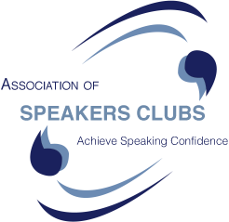

Achieving Speaking Confidence
The ASC has
- 100 affiliated clubs in UK (locations on website)
- over 40 years experience of helping people
- enables you to practise, practise, practise
- useful resources – tips, tricks, techniques
- a programme to help you improve

- and FUN!

01535 652915

Lose your Fear
of Public Speaking

It’s a fear that affects over 90% of the population, yet for those of us who are willing to overcome it, great rewards await

What is a Speakers Club?
Speakers Clubs exist with the aim of giving you a safe environment in which to increase you confidence in speaking to an audience.. A structured 10 step process ensures everyone keeps improving. For example, the level 1 speech is a 5 minute talk on a subject of your choice with no pressure and lots of support from the group.

Tips, Tricks, Techniques ...& Fun
One member said: “I am really glad I started. My speech making has improved so much. I have met a great new group of people. I really do wish I had started at the beginning of my career.”

Craven Speakers Club, Skipton
Meets fortnightly Sept – May, Monday evenings at The Soroptimists Rooms. 28 Otley St, Skipton,
BD23 1EW www.craven-speakers.org.uk
(50% Discount for people aged 16-18)
info: 07984181587 01535 665278. You gain:-

Fun, Support, Improvement
Join one of the 100 speakers clubs in the UK
www.the-asc.org.uk


Help
yourself - and - others
Improve self confidence & speaking skills

Tips, Tricks, Techniques ...& Fun
at
Craven Speakers Club
Skipton
at the Soroptimists Rooms, 28, Otley St, BD23 1EW

Alternate Mondays:
7.40pm 14, 28 Sept,
12, 26 Oct; 9, 23 Nov; 7 Dec

www.craven-speakers.org.uk
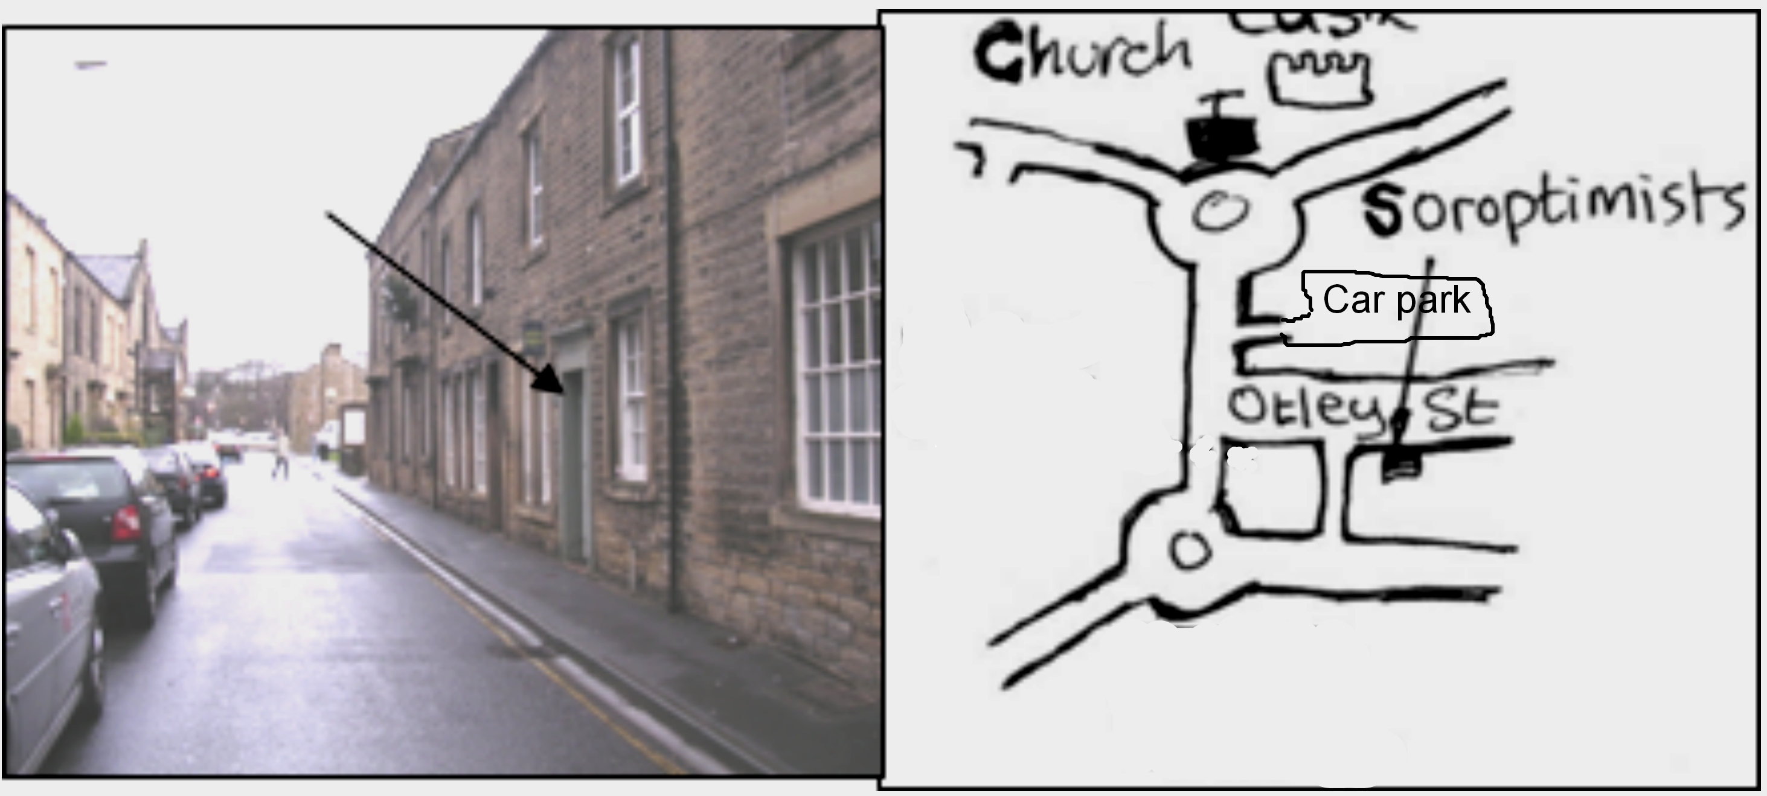
www.the-asc.org.uk

Visitors Welcome

More clubs at: York, Wetherby, Otley, Leeds, Halifax, Clitheroe, Burnley+ Bradford but Craven at Skipton is the best!! 01535-652915

Job adverts show that Employers
need people with good communication
skills…… So ……

Learn to
Speak well

Come to
Craven Speakers Club, Skipton
The Soroptimists Rooms, 28, Otley St, BD23 1EW
Alt. Mondays - 7.40pm  14, 28 Sept, 12, 26 Oct;  9, 23 Nov; 7 Dec  www.craven-speakers.org.uk  www.the-asc.org.uk | *** speaking to an audience***  # School project - # Wedding -  # Business meeting - # Public talk - or just to your friends  Give it a try - Visitors Welcome  01535-652915

Wedding Speeches
Business Presentations
Student project talks:

Learn to
Speak well

Introductory course
Alt. Mondays - 7.40pm
Craven Speakers Club
Skipton
The Soroptimists Rooms, 28, Otley St, BD23 1EW
14, 28 Sep, 12, 26 Oct; 9, 23 Nov; 7 Dec  www.craven-speakers.org.uk  www.the-asc.org.uk | *** speaking to an audience***  Give it a try  Visitors Welcome  01535-652915

When giving a speech do you
Stumble,
mumble
and grumble?

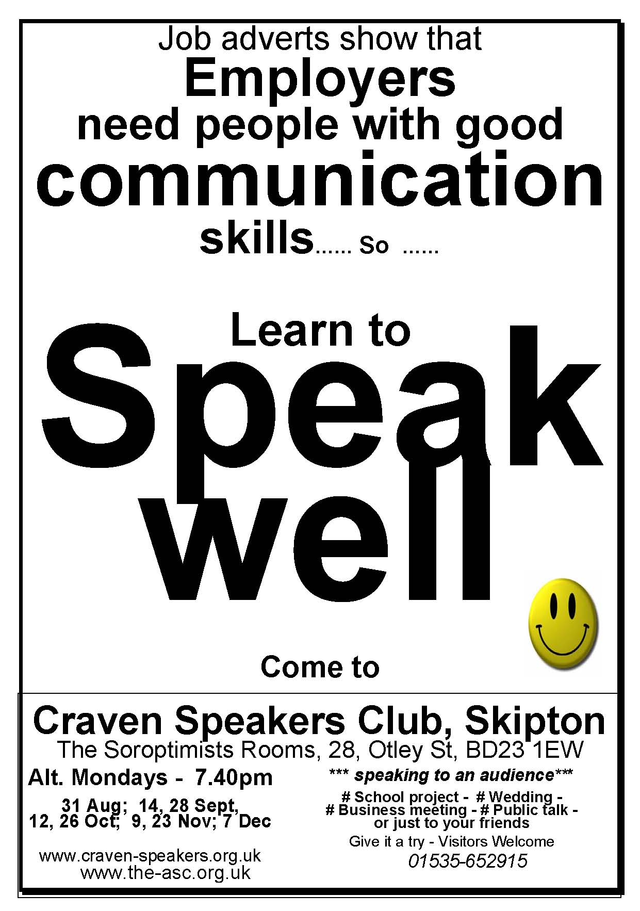
After attending Craven Speakers Club you'll be:
Shoulders back.
Smile.
Look them in the eye.
And then..
and then..
......... suspense!
You'll have them eating out of your hand!
You just need practice, practice and encouragement..
and that is what Speakers Club will give you. (And which reading a book, or attending a £500 weekend course cannot do)

In front of an audience, do you
Bumble,
stumble
and tumble?

Get organised!
With the help of Craven Speakers Club, and the supportive practice there, you'll:-
- Tell the audience three ways they will benefit from hearing your speech
- Tell them three things that will benefit them
- Recap, and give them a definite call to action:
e.g. "Come to Speakers Club next Monday!"
.
.
Does an audience make
Your words jumble,
Your stomach rumble,
Your world crumble?

You know what to do...

.
Does an audience make
Your words jumble,
Your stomach rumble,
Your world crumble?

You know what to do...

